Physics 3A/3B

Motion and Forces in Magnetic and Electric Fields

TEST



Time allowed: 70 min
Answer all questions on the paper provided
To achieve full marks, clear, logical
working and diagrams MUST be shown.
Answers should be evaluated with an
appropriate number of significant figures.

Name

Score | /45

Section A: 5 short answer questions 15 marks

- When drawing field lines around point charges, they are drawn such that the lines are closer together near the point charge but further apart as you move away.

  - Explain what this tells us about the fields around point charges.
(1 mark)

In parallel plates however, the lines are drawn parallel and the same distance apart.
  - Why is this different to point charges?

(1 mark)

- Draw the electric field lines for the following two situations.
  - Two positively charged point charges.

(2 marks)

  - A positive point charge above a negatively charged plate

(2 marks)

- A pith ball (small foam ball) has been given a charge of -8.45 x 10⁻² μC and is placed within an electric field. The pith ball experiences a force of 4.25 x 10⁻⁴ N north.

Calculate the magnitude and state the direction of the field at that point.

(3 marks)

- What is the force on an electron which is moving horizontally with a constant velocity of
8.25 x 10⁷ m s⁻¹ south when it enters a uniform magnetic field of 5.5 x 10⁻³ T east.

(3 marks)

- The diagram below shows a uniform magnetic field with three particles A, B and C having masses and charges as shown in the table below. They each enter the magnetic field with the same velocity, v. Complete the diagram to CLEARLY show the direction and relative radii of the paths of particles A, B and C. (relative to each other)
(3 marks)

Particle | Relative charge | Relative mass
A | 1 + | m
B | 2 + | 2m
C | 1 - | m

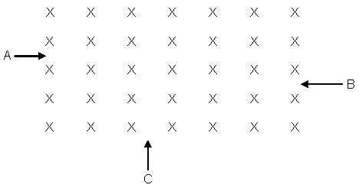
(3 marks)
Section B: 4 Extended answer worth 30 marks

- In an experiment, two parallel plates are set up in a vacuum. The plates are 2.50 cm apart and connected to opposite terminals of a 240 V power supply.

  - Determine the magnitude of the electric field between the plates.

(2 marks)

  - Calculate the force the electric field exerts on an electron within the field.

(2 marks)
  - Calculate the lost in potential energy for an electron as it leaves the negative plate and hits the positive plate.

(2 marks)

  - Calculate the maximum speed of the electron.

(2 marks)

- A charged particle of mass 3.80 x 10⁻⁶ g is suspended between two plates as shown. The plates are 5.45 mm apart.

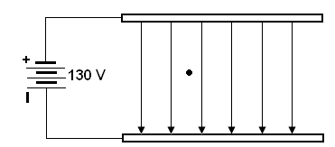

- Determine the strength of the electric field between them.

(2 marks)

- Calculate the charge on the particle.

(3 marks)

- The charge is due to a number of excess electrons on the particle. Calculate the number of excess electrons

(2 marks)

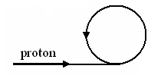
- A proton experiences a force of 2.11 x 10⁻¹⁴ N when it enters a magnetic field as shown in the diagram. The velocity of the proton is 1.50 x 10⁶ ms⁻¹.

- Describe the direction of the magnetic field.
(1 mark)
- Calculate the strength of the magnetic field that is acting on the proton.

(2 marks)
- What is the diameter of the path followed by the proton?

(3 marks)
- Calculate the frequency of the path of the proton.

(2 marks)

.
- A beam of gaseous ions can be separated into components with different values of mass divided by charge. The result is a mass spectrum. Most measurements are made with singly charged positive ions so the spectrum is divided simply according to mass.

When the ion beams are detected with an electrometer the instrument is called a mass spectrometer. The diagram below shows a mass spectrometer.

A stream of singly- charged positive ions of chlorine isotopes ³⁵Cl⁺ and ³⁷Cl⁺ emerge from the slit with speeds of 2.5 x 10³ ms⁻¹. They are then deflected by a magnetic field of uniform flux density 2.00 mT.

The mass of ³⁵ Cl⁺ is 5.81 x 10⁻²⁶ kg and the mass of ³⁷Cl⁺ is 6.14 x 10⁻²⁶ kg.
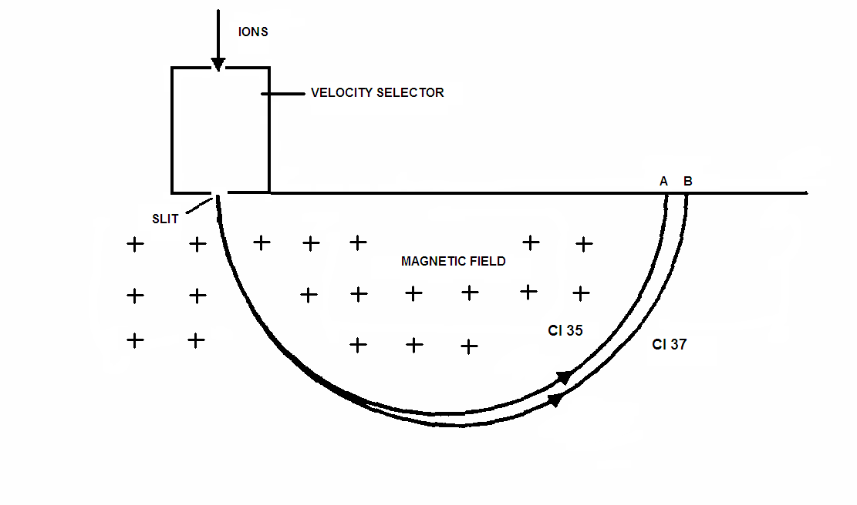

- Describe the function of the velocity selector and briefly explain the principles of its operation

(3 marks)
- Calculate the separation between points A and B

(4 marks)

